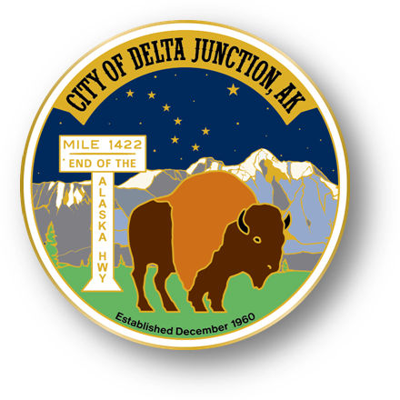

City of Delta Junction

Welcome to the Friendly Frontier

Welcome to the Friendly Frontier
PO Box 229, Delta Junction, Alaska 99737
Ph 907-895-4656 Fax 907-895-4375
www.deltajunction.us
city@deltajunction.us

Mary Leith
Deputy Mayor, Seat A
Term Expires 2027

Stormie Mitchell
Council Seat B
Term Expires 2025

Mike Prestegard
Council Seat C
Term Expires 2026

Igor Zaremba
Mayor, Seat D
Term Expires 2025

Lance Stricklin
Council Seat E
Term Expires 2027

Pete Hallgren
Council Seat F
Term Expires 2026

Travis Riesner
Council Seat G
Term Expires 2025

To listen to the meeting, go to KDHS 95.5 FM radio or http://streema.com/radios/KDHS_LP

To attend via zoom, email finance@deltajunction.us for link and access code

Special Meeting, Council Agenda

5:00PM, Tuesday, October 29, 2024

City Hall, Delta Junction, Alaska

CALL TO ORDER PLEDGE AND PRAYER

NEW BUSINESS
- Public Works Truck

ADJOURNMENT

Upcoming Council Meetings
City Hall, Library, Landfill closures

Tuesday, November 5, 2024
Monday, November 11, 2024 (Veterans Day)
Tuesday, November 19, 2024
Thursday, November 28, 2024 (Thanksgiving)
Friday, November 29, 2024 (extended Thanksgiving)

