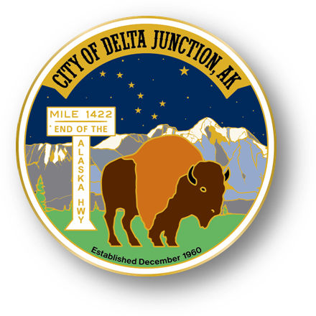

City of Delta Junction

Welcome to the Friendly Frontier

Welcome to the Friendly Frontier
PO Box 229, Delta Junction, Alaska 99737
Ph 907-895-4656 Fax 907-895-4375
www.deltajunction.us
city@deltajunction.us

Mary Leith
Deputy Mayor, Seat A
Appointment Expires 2024

Vacant
Council Seat B
Term Expires 2025

Mike Prestegard
Council Seat C
Term Expires 2026

Igor Zaremba
Mayor, Seat D
Term Expires 2025

Lance Stricklin
Council Seat E
Appointment Expires 2024

Pete Hallgren
Council Seat F
Term Expires 2026

Travis Riesner
Council Seat G
Term Expires 2025

To listen to the meeting, go to KDHS 95.5 FM radio or http://streema.com/radios/KDHS_LP

To attend via zoom, email finance@deltajunction.us for link and access code

Regular Meeting, Council Agenda

5:00PM, Tuesday, September 17, 2024

City Hall, Delta Junction, Alaska

CALL TO ORDER PLEDGE AND PRAYER

AMENDMENTS ~ APPROVAL OF AGENDA
- September 17, 2024 Regular Meeting

AMENDMENTS ~ APPROVAL OF MINUTES FROM PREVIOUS MEETING
- September 3, 2024 Regular Meeting
Speaker must be recognized by the Chair. State name and organization. Address the Council body and limit comments to three minutes.

COMMENTS ON NON-AGENDA ITEMS

REQUEST TO SPEAK - none

CORRESPONDENCE – none

UNFINISHED BUSINESS
- Tenderfoot Gold

NEW BUSINESS
- Watson Replat Preliminary Approval
- Landfill Scale House Boiler
- Landfill Loader
- IDI Independent Dispatch, Inc. Rock Screen 14ft Rip Rap $11,500.00
- City Council Regular Meeting October Date Change
- City Purchases over $1,000
CK #23240 to Bank of America $7,841.92 for July 2024 Credit Cards Purchases
CK #23241 to Koppers Communication - $23,315.76 Deposit for Security System Approved at Sept. 3rd Meeting
CK #23242 to ACS - $1,151.65 for September 2024 Telephones and Internet
CK #23243 to City of Fairbanks - $41,230.00 for 2024 Dispatch Contract
CK #23244 to FLUENT IMS - $1,200.00 for 2024 VFD Subscription
CK #23245 to Grainger- $2,220.27 for Crosswalk Signs & Milepost Caution Signs
CK #23246 to GVEA- $4,392.51 for August 2024 Electricity
CK #23247 to Hale & Associates - $13,189.54 for FY25 Adjusted Premiums: Workman’s Comp. & General Liability
CK #23248 to Interior Hardware - $2,343.17 for August 2024 Supplies: Paint Sprayer, Hoses, Splice Kit, Gaskets
CK #23249 to Spartan Services - $4,911.19 for City Hall Carpet Cleaning – Flood Damage
CK #23250 to Vitus Energy LLC - $7,148.62 for June-September 2024 Heating Fuel
CK #23251 to Wells Fargo CC - $7,425.00 for July & August Credit Cards

REPORTS

Upcoming Council Meetings
City Hall, Library, Landfill closures

Tuesday, October 1, 2024
Tuesday, October 8, 2024
Tuesday, October 15, 2024

Mayor – Igor Zaremba
City Administrator – Lori Roberts
Finance – Kaylee Reierson
Library – Mary Leith
Health & Safety – Travis Riesner
Emergency Preparedness – Travis Riesner
Schools –
Emergency Services –
Park & Recreation – Igor Zaremba
MUNICIPAL ELECTION
8:00am to 8:00pm
Tuesday, October 1, 2024
Community Center

Certify Election Results
Tuesday, October 8, 2024

Elect Mayor and Deputy Mayor
Tuesday, October 15, 2024

Landfill – Igor Zaremba
Airport – Mike Prestegard
Public Works – Mike Prestegard
At Large – Pete Hallgren
Cemetery – Pat White
City Clerk – Pat White
Additional Reports –

ADDITIONAL PUBLIC AND COUNCIL COMMENTS
ADJOURNMENT

